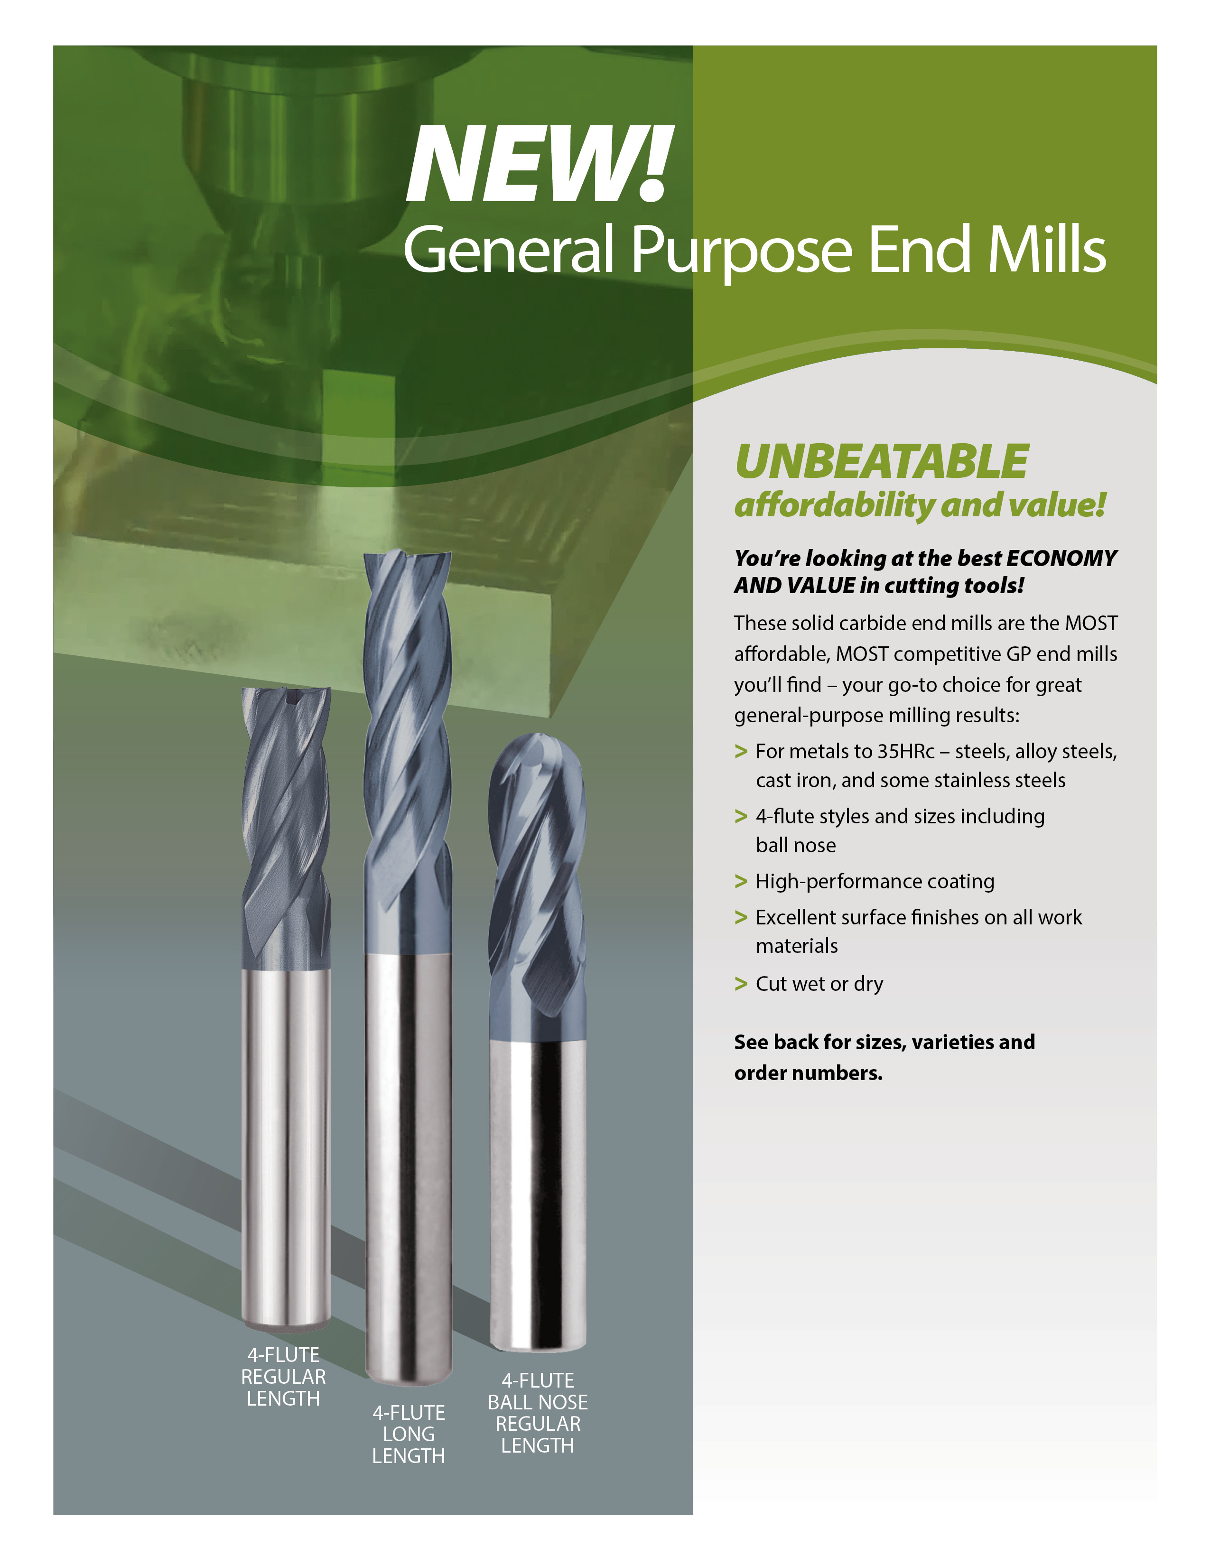

*Distributor logo area*

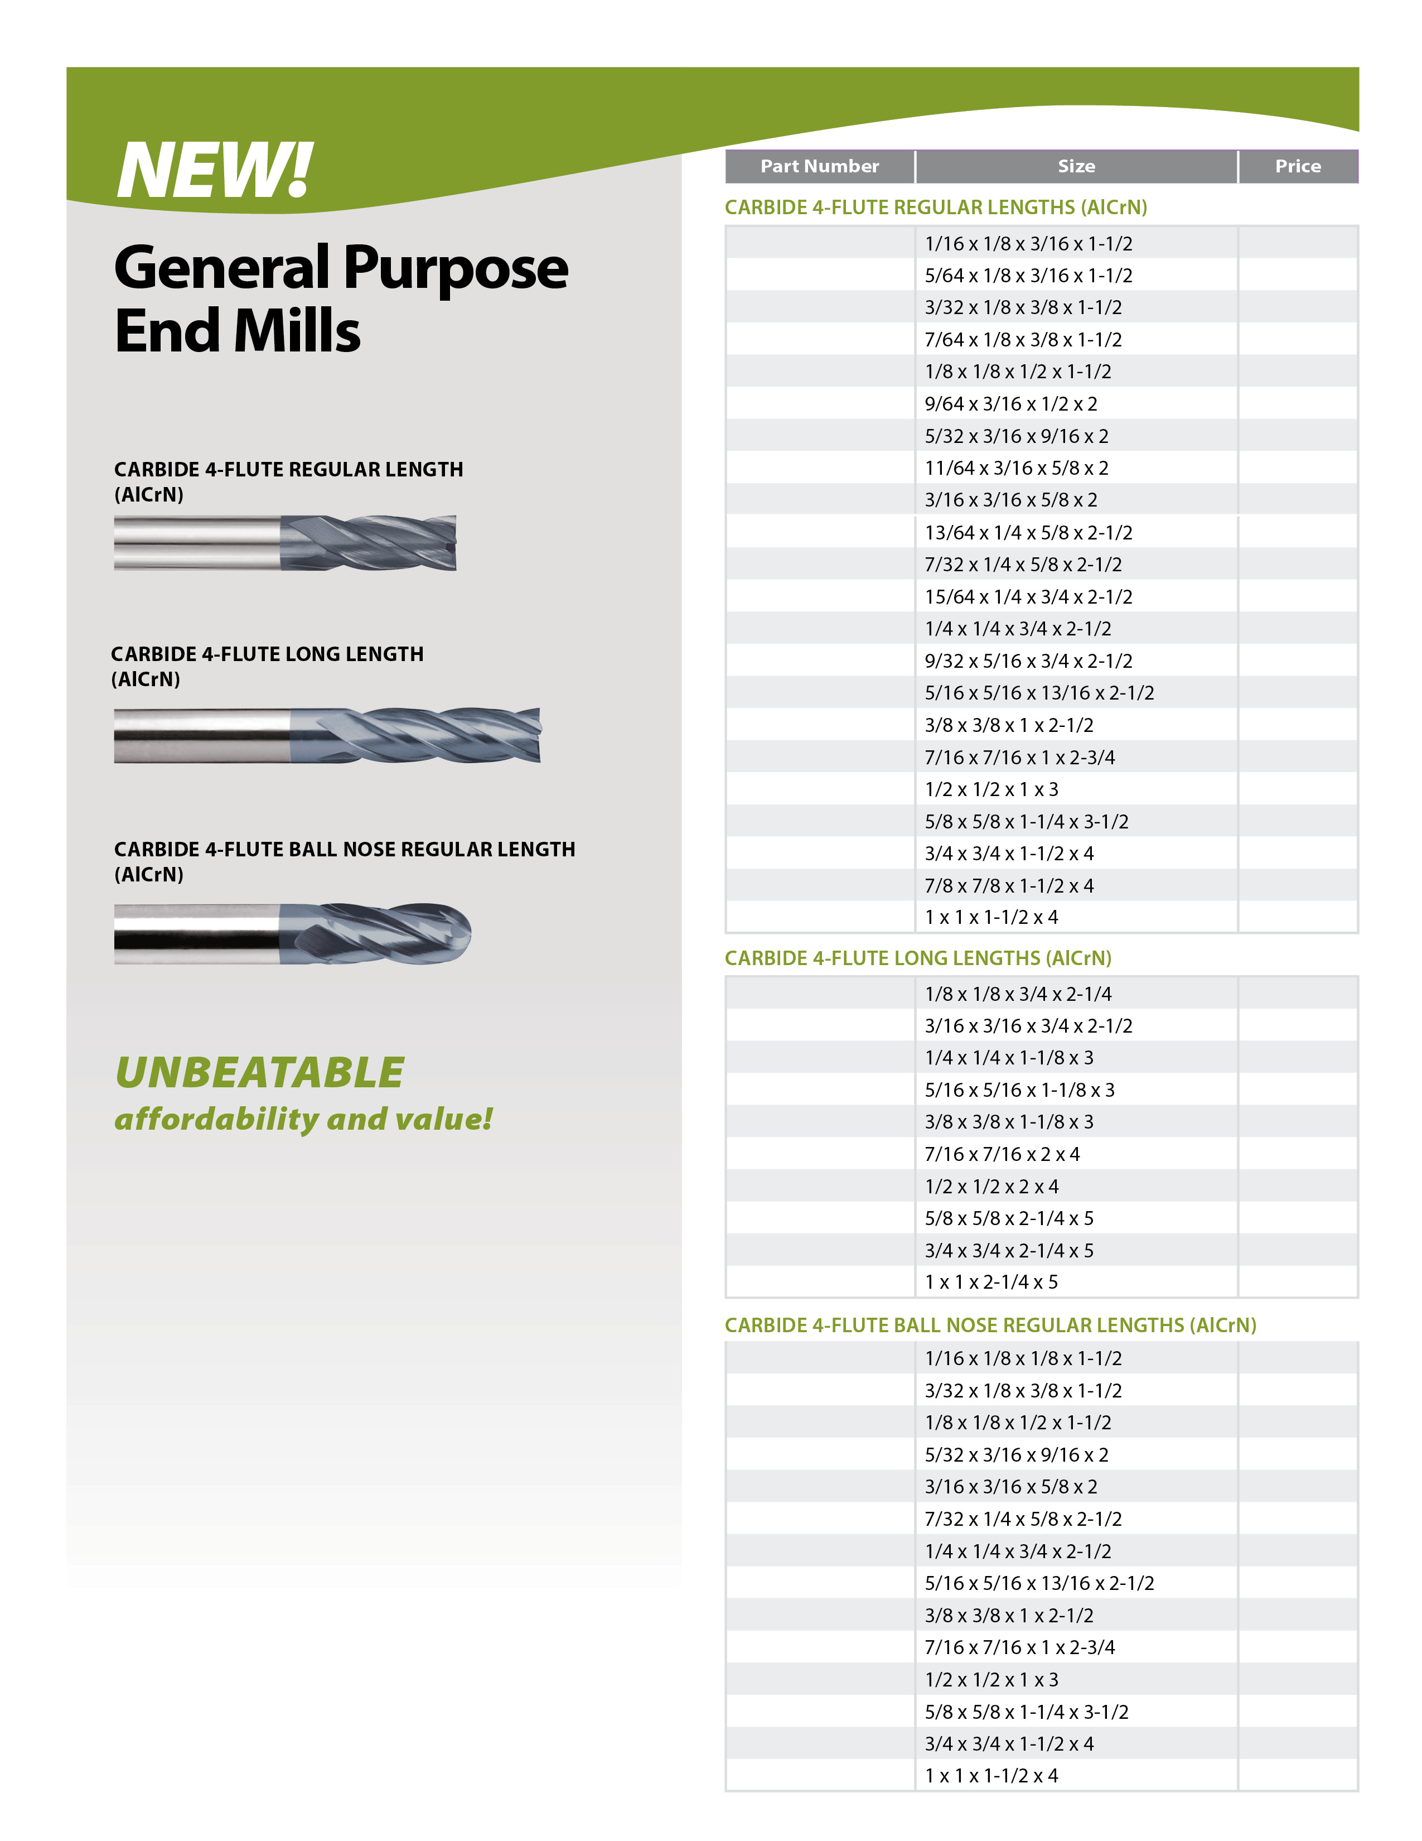

$000.00

$000.00

$000.00

$000.00

$000.00

$000.00

$000.00

$000.00

$000.00

$000.00

$000.00

$000.00

$000.00

$000.00

$000.00

$000.00

$000.00

$000.00

$000.00

$000.00

$000.00

$000.00

000000000

000000000

000000000

000000000

000000000

000000000

000000000

000000000

000000000

000000000

000000000

000000000

000000000

000000000

000000000

000000000

000000000

000000000

000000000

000000000

000000000

000000000

000000000

000000000

000000000

000000000

000000000

000000000

000000000

000000000

000000000

000000000

$000.00

$000.00

$000.00

$000.00

$000.00

$000.00

$000.00

$000.00

$000.00

$000.00

Distributor contact information

*Distributor logo area*

$000.00

$000.00

$000.00

$000.00

$000.00

$000.00

$000.00

$000.00

$000.00

$000.00

$000.00

$000.00

$000.00

$000.00

000000000

000000000

000000000

000000000

000000000

000000000

000000000

000000000

000000000

000000000

000000000

000000000

000000000

000000000