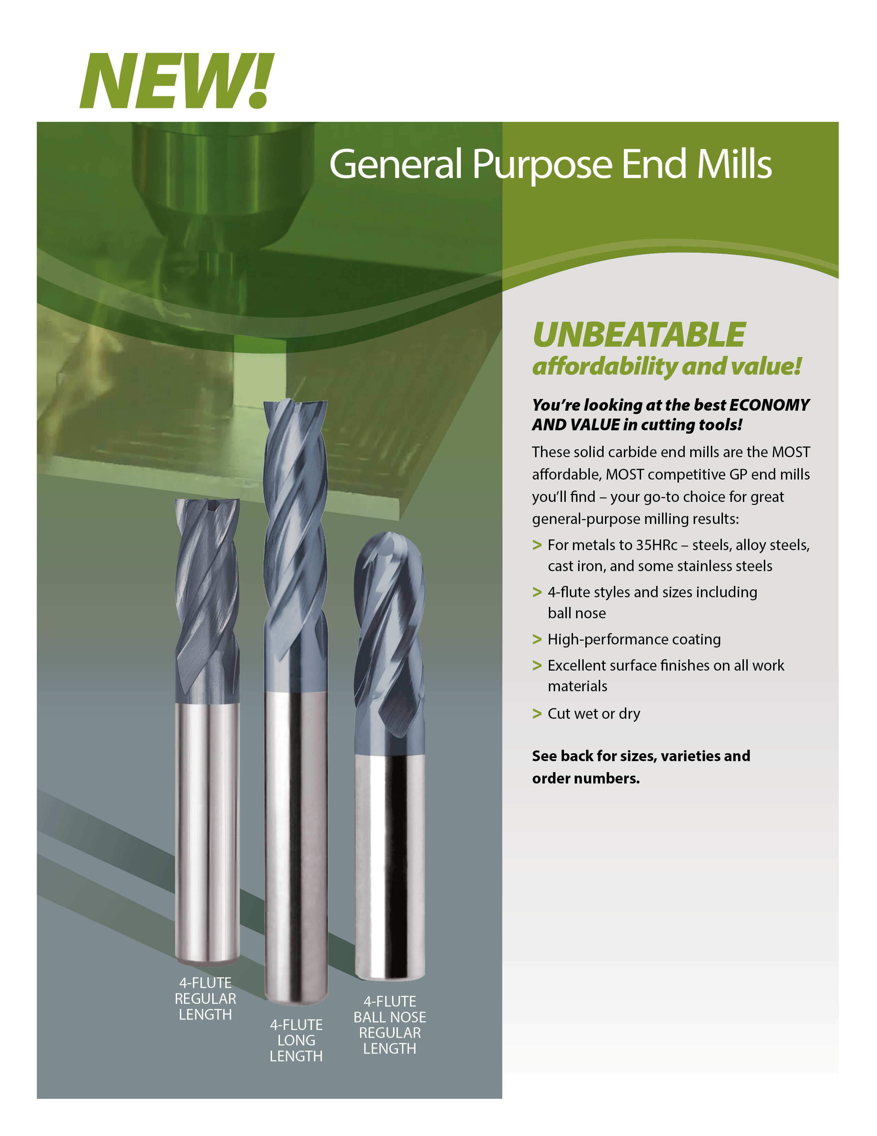

*Distributor logo area*

**Name Here**

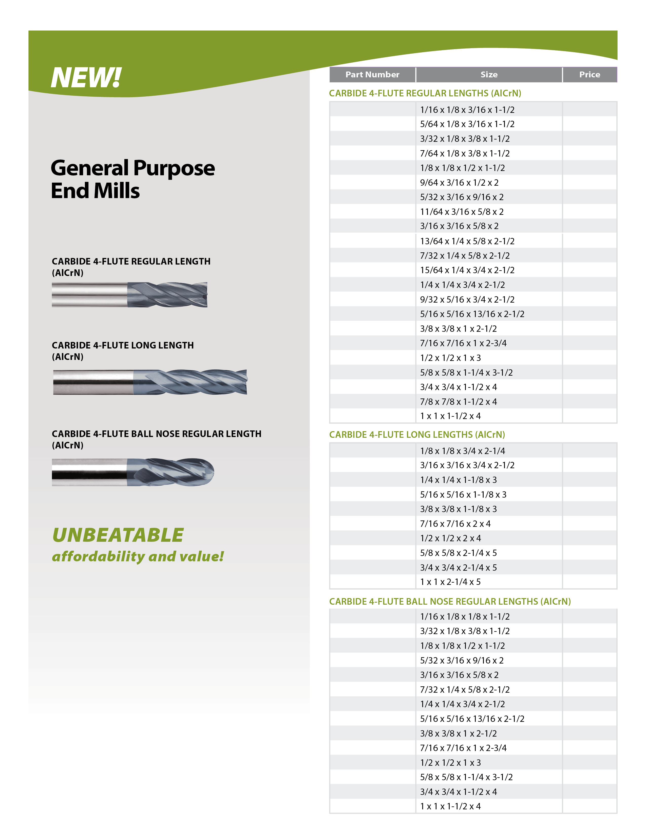

000000000

000000000

000000000

000000000

000000000

000000000

000000000

000000000

000000000

000000000

$000.00

$000.00

$000.00

$000.00

$000.00

$000.00

$000.00

$000.00

$000.00

$000.00

000000000

000000000

000000000

000000000

000000000

000000000

000000000

000000000

000000000

000000000

000000000

000000000

000000000

000000000

$000.00

$000.00

$000.00

$000.00

$000.00

$000.00

$000.00

$000.00

$000.00

$000.00

$000.00

$000.00

$000.00

$000.00

$000.00

$000.00

$000.00

$000.00

$000.00

$000.00

$000.00

$000.00

$000.00

$000.00

$000.00

$000.00

$000.00

$000.00

$000.00

$000.00

$000.00

$000.00

$000.00

$000.00

$000.00

$000.00

000000000

000000000

000000000

000000000

000000000

000000000

000000000

000000000

000000000

000000000

000000000

000000000

000000000

000000000

000000000

000000000

000000000

000000000

000000000

000000000

000000000

000000000

**Name Here**

Distributor contact information

*Distributor logo area*